**Safe and Speed-up Drilling Technology for Ultra Deep Well Based on Geology-Engineering Integration**

Changchang Chen 1,Guodong Ji 1,2, Haige Wang 1,2, Hongchun Huang 1,Qiang Wu1,Li Liu 1

*1 CNPC Engineering Technology R&D Company Limited, Beijing 102206, P. R. China*

*2 CNPC Research Institute of Petroleum & Development, Beijing 100083, P. R. China*

*Corresponding author.

E-mail address:chenccdr@cnpc.com.cn (C. Chen); 772920980@qq.com (G. Ji).

**Abstract**

Qiulitage tectonic belt in Tarim Basin has large reservoir burial depth and complex geological conditions, and challenges such as ultra deep, high temperature, high pressure and high stress lead to big problems related to well control safety and project quality. To solve these key technical problems that set barriers to the process of exploration and development, a set of drilling technology process geology-engineering integration is established with geomechanics as the bridge. And an integrated key drilling engineering technology for the safe speed up of ultra deep well was formed, integrating well location optimization, well trajectory optimization, stratum pressure prediction before drilling, stratum drillability evaluation, bit and speed-up tool design and optimization. Combined with seismic data, logging data, structural characteristics, and lithology distribution characteristics, the rock mechanics data volume related to the 3D drilling resistance characteristics of the block was established for the first time, and the vertical and horizontal heterogeneity was quantitatively characterized, which provided a basis for bit design, improvement and optimization.During the process of drilling, the geomechanical model shall be corrected in time according to the actual drilling information, and the drilling "three pressures" data shall be updated in real time to support the dynamic adjustment of drilling parameters.Through field practice, the average drilling complexity rate was reduced from 12% to 4.6%, and the drilling cycle at 8500m depth was reduced from 326 days to 257 days, which were significantly better than those of the vertical wells deployed in the early stage without considering geology-engineering integration.

**Key words：** Tarim Basin; Qiulitage; geology-engineering integration; Ultra deep well; Safe drilling; Full hole speed up

**1 Introduction**

Geology-engineering integration, with its features being systematically and continuously optimizing the technical combination and solutions in the exploration and development of oil and gas fields through continuous self-learning and experience accumulation, can solve the engineering problems caused by complex geological conditions to the greatest extent, and its ultimate goal is to improve the operation efficiency, reduce the complexity of accidents and improve the per-well productivity (Xian et al., 2017; ZOBACK M D et al., 2010).

The main idea of geology-engineering integration is to predict geological parameters related to drilling and well completion quality through comprehensive research integrating oil and gas reservoir characterization, geological modeling, geomechanics and oil and gas reservoir engineering evaluation. Geomechanics modeling works as a bridge in geology-engineering integration, so as to ensure the seamless connection between geological knowledge and engineering technology and effectively solve the engineering problems, and improve the operating efficiency and development benefit through engineering application, in which way, achieve cost reduction and efficiency increase (Ma Y Z et al., 2011;Yu et al., 2011). In 2011, cipolla et al (CIPOLLA C L et al., 2011) Proposed the integrated workflow of "from earthquake to simulation" for the first time in view of the challenge of unconventional reservoir development, seamlessly integrating the whole process research method from seismic data interpretation to productivity simulation. From 2012 to 2016, during the development of Marcellus, eagleford and other shale, the integrated geological engineering method was widely used to carry out scheme design, parameter optimization and other work (GUPTA J K et al., 2012;MARONGIU-PORCU M et al., 2015). Wu Qi and others systematically put forward the concept and technical route for the integrated development of marine shale gas geological engineering in southern China, and took the lead in applying the "quality triangle" in huangjinba ys108 block (Wu et al., 2015). Hu Wenrui and others elaborated the concept, connotation and realization conditions of geological engineering integration in detail(Hu et al., 2017). In addition, bhge, Schlumberger, Halliburton and other companies have actively cooperated with the oilfield to provide integrated geological engineering services and software platforms to provide technical support for unconventional reservoir development. In practice, the unique geological engineering integration technology has been gradually explored (COHEN C E et al., 2014;MAXWELL S C et al., 2013;WENG X et al., 2014;).

In this paper, in view of the engineering problems faced in the scientific development of Zhongqiu block of Qiulitage, such as high-yield well location deployment, well trajectory optimization, drilling safety and speed increase, a geology-engineering integration collaborative platform was built up, an integrated implementation process was established, a series of key technologies were formed through research, so as to gives full play to the advantages of multidisciplinary collaborative work. Taking well Zhongqiu 10 as an example, the practice of safe speed-up technology of drilling based on geology-engineering integration was described in detail. The research result can support the efficient development of newly discovered gas reservoirs and help the construction of large oil and gas fields.

**2 Geological Background and Difficulties in Drilling**

The north of Kuqa depression where Qiulitage tectonic belt is located is connected with the South Tianshan fault fold belt by thrust fault, and the south to it is Tabei uplift (Fig. 1). Both the surface and the underground geological structures of Zhongqiu block are very complex (Jia et al., 1999; Tang et al., 2006). Under the action of strong compressive stress, a series of folds, fold-related faults and sudden structures are engineering problemformed along the deep detachment layer, bringing many s to well drilling and completion: ① the uneven mountain surfaces bring difficulties to well site selection and surface engineering; ② The “roof shape” of the shallow layer leads to the high and steep stratum (the dip angle of the stratum reaches70 ° in some places) and the development of fault, which can easily cause the instability of the hole wall and complex drilling accidents. In addition, the poor drillability of the huge thick gravel layer deposited in the shallow part (up to 4500m thick) is one of the biggest problems restricting the drilling efficiency; ③Mudstone, gypsum salt and salt rock interbed and cross with each other in plastic stratum, and the thickness variation is large (hundreds of meters to 4000 meters). Thus, the physical and chemical effects during the drilling may cause complex hole environment with the coexistence of collapse, leakage and overflow, which resulting in difficult drilling and high safety risk; ④The subsalt strata are highly overlapped, faults are developed, and the risk of hole instability is high. On the other hand, the extreme conditions of “high temperature, high pressure and high stress” brought by the large buried depth (up to 8200 m) of the subsalt reservoir exacerbate the safety risk of well control and the difficulty of reservoir reconstruction. Taking the Zhongqiu structure in the middle of Qiulitage tectonic belt as an example, the south is controlled by Keshen fault, and the north is controlled by the third-order fault, the south fault of Awa 4 structure, the south fault of Bozi 15 structure and the south fault of Bozi 17 structure. The strata are in normal sequence. The suprasalt stratum is from Xiyu formation to Paleogene Suweiyi formation, and huge thick gravel layer is developed with the maximum drilled thickness of 4800m. The gravel layer has low stratum strength with inversion stress field at some local, causing serious hole wall collapse and poor drillability of Lv. 7~10, indicating a high drilling resistance stratum. And due to different diagenesis (Xiong et al., 2009), The leakage loss in the drilling of shallow non diagenetic gravel stratum is serious while the plugging is difficult. In the suprasalt stratum, from the Neogene Jidike formation to the Paleogene Suweiyi formation are highly argillaceous, and in the clay mineral contents, montmorillonite accounts for 7.0% ~ 10.3%, of which the experimental analysis showed that the hydration was strong, and the actual drilling showed that the phenomena of collapse, drill pipe sticking and bit balling were serious. The Paleogene Kumegliemu group is a composite salt layer mainly composed of salt rock, gypsum, dolomite and mudstone interlayer, with a maximum buried depth of 6300m. The practical drilling analysis found that the formation had strong creep (Wang et al., 2013; Li et al., 2006), and pore fluid existed in the dolomite and siltstone formation mixed with the salt, which made it easy to leak. High-pressure brine exists in some parts. Thus, the risk of well control is high. The subsalt stratum is a fractured sandstone stratum partially mixed with silty mudstone and conglomerate. The practice drilling showed that this stratum was highly abrasive, both leakage and resistance happened during the drilling, and the leakage was highly possible to develop into blowout. Thus, the drilling safety effect needs to be further improved.

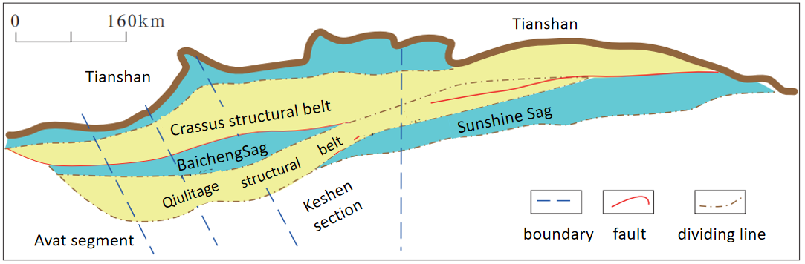

**Fig. 1.** Tectonic location map of the study area

**3 Practice of Drilling Technology Based on Geology-Engineering Integration**

***3.1 Geomechanical model construction***

As the subsalt imbricate reservoirs layers develops in a staggered overlapping feature in Qiulitage tectonic belt, in this study, the reverse finite element method was used to establish the 3D crustal stress field model of the whole stratum of Zhongqiu structure (Fig. 4-A)(Rojas et al., 2020). In this model, the longitudinal resolution of the model was 2 ~ 5m, in which, the distribution of natural fractures and their activity (expressed by the ratio of shear stress to normal stress of fracture surface in this paper) (Fig. 4-b) were predicted, with the cold color standing for the crack with poor activity, and the warm color for the crack with good activity. Firstly, establish the geological geometric model of the whole stratum system, and after the preprocesing of point cloud data thinning, local encryption and cutting, adapt the idea of reverse finite element engineering modeling for the purpose of establishing a continuous and regular level to meet the crustal stress simulation, so as to overcome the technical problems of reverse fault and repeated strata modeling in the modelling of continuous crustal stress and accurately solve the complex intersection relationship between fault and stratum.(GALE J F W et al., 2008) Secondly, adapt the X-Y two-way difference iteration method to iteratively scan some long conjoined anticline with large fluctuation and span, so as to further improve the accuracy of reverse finite element modeling; Through the finite element model and geological point cloud calculation and analysis, adjust the modeling error of local elements. Then, through the virtual geometric level in the finite element model, the mesh refinement and coarsening of the crustal stress model are flexibly realized, and the crustal stress mesh continuous model of superimposed nappe is established. Finally, considering the magnitude and direction of crustal stress at well points, determine the boundary load constraints of the model to realize the crustal stress field modeling of the whole layer system of large deformation geological body.

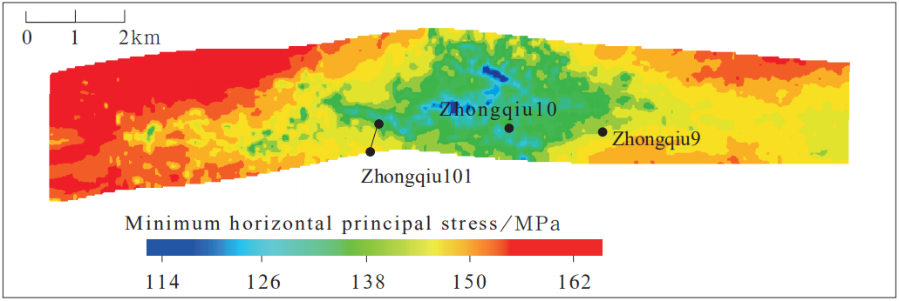

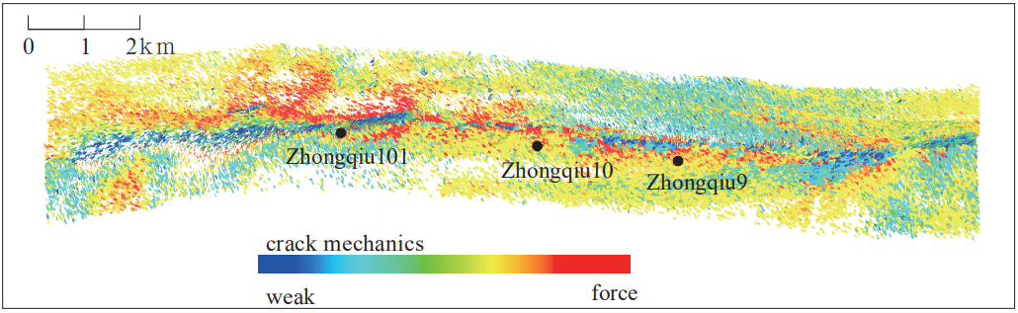

（a）Plane distribution of minimum horizontal principal stress

（b）Distribution of predicted fracture mechanical activity

**Fig. 2.** 3D geomechanical model of Zhongqiu block

***3.2 Well location optimization and well trajectory optimization***

It was found from the drilled well in Qiulitage tectonic belt that great differences in per-well productivity, drilling borehole wall stability and stimulation effect of well completion reconstruction occurred between the same tectonic belt or different tectonic belts. As well, reservoir fractures develops and are highly heterogeneous, and the degree of fracture development and potential mechanical activity are the main factors affecting per-well productivity. The research suggested that the distribution of stress field in reservoir section controlled the distribution of natural fractures. The natural fractures in low stress area are developed and easy to be fractured in the later stage, resulting in high productivity and good stability of drilling hole. Based on the above knowledge, the well location and well trajectory optimization technology that includes 4 factors, namely, consider the shallow complex structure, avoid high-risk area for borehole wall stability, consider fracture development orientation with good activity, and

prefer low stress area, was proposed. Taking the deployment of well Zhongqiu 10 in Zhongqiu fault block as an example, the drilling in this fault block encounters shallow nappe, so the risks of sticking and casing collapse are high. Due to this, Zhongqiu 10 well is planned to be drilled with a highly inclined well type to avoid the hanging wall nappe and the complex shallow surface, so as to prevent large scale of leakage, block falling, sticking and other complex and the failure to drill and uncover the target layer during drilling, in order to achieve the purpose of geological drilling. Meanwhile, considering the factors such as borehole wall stability, permeability fracture (INFANTE E F et al., 2013; Cozyris et al., 2015) encountered in drilling, and easy later reconstruction. The finite element simulation method based on structural horizon control was adopted to establish the 3D crustal stress field model of well Zhongqiu 10 (Fig. 3). The modeling results suggested that the lowest stress (blue area) in Figure 3 should be the best target location for well point deployment. On the one hand, from the previous drilling experience and borehole wall stability evaluation, multiple sets of pressure systems coexist, the longitudinal variations of leakage pressure and stratum collapse pressure are large, and there is no drilling fluid density window in local intervals, and under this strike slip stress state, vertical well is the most unstable well type and drilling can not be realized; On the other hand, according to the actual drilling analysis of well Zhongqiu 9, this area belongs to fractured reservoir, and the angles of the majorities of the fractures are high. Thus, vertical well can not guarantee the accurate vertical crossing of the fractures, which is not conducive to production increase. Considering this, the well type of highly inclined well was determined for the drilling. First determine the target according to the stress field and fracture mechanical activity distribution,then evaluate the development orientation of natural fractures with good permeability after considering the actual drilling results of adjacent wells, and determine the drilling orientation conducive to borehole wall stability. On the basis of meeting the requirements of surface conditions and hole structure, the wellhead position and target orientation of the well are finally determined at 10 ° in the northeast direction with a hole inclination of 70 °. The actual target orientation of the well was 15 °, the hole inclination was 76 °, and the closure distance was 1221m. To reach the target layer, only 33 days were costed, and the average daily footage was 11.5m. No any drilling complex events such as drilling fluid leakage has happened. The transformation method of two-stage sand fracturing was adopted for the well completion and production. Nozzle dia. was 9mm, tubing pressure was 75.7mpa and daily gas equivalence production was 74×104m3 which was three time as that of other wells in the same block. Well Zhongqiu 10 was the first successful highly inclined well drilled in Qiulitage complex tectonic belt and achieved high production, which laid a good foundation for the promotion of highly deviated wells in the block and explored a new well type for efficient development.

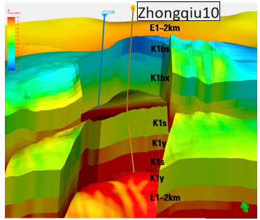

**Fig. 3.** 3D geomechanical model of Zhongqiu 10 structure

***3.3 Pre-drilling pressure prediction***

Accurate stratum pressure prediction is an important basis for well control safety guarantee and drilling fluid density design. However, due to the complex geological conditions of Qiulitage tectonic belt , the coexistence of multiple sets of pressure systems, the development of extremely thick gypsum salt rock stratum and the limited quality of seismic data, it is difficult to accurately predict the stratum pressure. Establish the stratum pressure prediction technology of well-seismic joint inversion (Wu et al., 2006) to obtain the regional high-precision data volume through well-seismic joint inversion, and then adopt the pressure prediction method of man-machine interaction to establish the nonlinear compaction trend to obtain the preliminary stratum pressure profile, and then calibrate the preliminary profile by using the measured drilling pressure data. And finally, obtain the 3D data volume of stratum pressure consistent with the geological background and engineering conditions, from which the data of newly deployed well points were extracted so that to obtain the stratum pressure profile and clarify the longitudinal distribution features for the purpose of the designing of the well structure and drilling fluid density. The pressure prediction method of well-seismic joint inversion can overcome the limitations caused by the monotonicity of the data, and the prediction accuracy is improved from less than 70% of the traditional method to 92%. Figure 5 shows the pre drilling stratum pressure prediction profile of well Zhongqiu 10, in which, the predicted stratum pore pressure coefficient rises from 3185m of Neogene Kangcun formation to 2.02 at the top of the gypsum salt rock section of Paleogene Kumgelimu group, and then decreases to 1.60 in Cretaceous Bashjiqik formation of the target layer. There is 1 fault and 1 set of salt layer developed in well Zhongqiu 10, the identified collapse pressure of the fault is 1.86g/cm3 and the leakage pressure is 2.15g/cm3. Through appropriate optimization of drilling fluid, the density of drilling fluid increased to 1.30g/cm3 at the middle layer of Kangcun formation, and at the top of gypsum salt rock section, with the increase of predicted pore pressure coefficient, the drilling fluid density increased to 2.30g/cm3, and then, at Cretaceous system, the drilling fluid density decreased to 1.70g/cm3 according to the predicted pore pressure data. No serious drilling complications such as overflow and leakage, happened in the whole well in the process, and the drilling was completed smoothly. The man-machine interactive pressure prediction method of well-seismic joint inversion was applied in the newly deployed wells in Qiulitage tectonic belt, and the model is under continuous correction with the completed drilling, resulting in the increasing coincidence rate between prediction and actual drilling from 70% to 92%, which greatly reduced the risk of overflow, leakage and sticking, significantly improved the drilling safety and reduced the non production time, and lays a foundation for the improvement of well control safety and drilling operation efficiency.

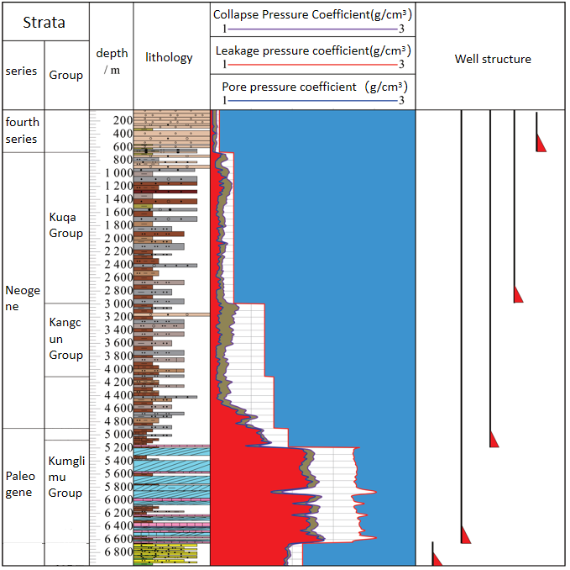

**Fig. 4.** Stratum pressure prediction profile of well Zhongqiu 10

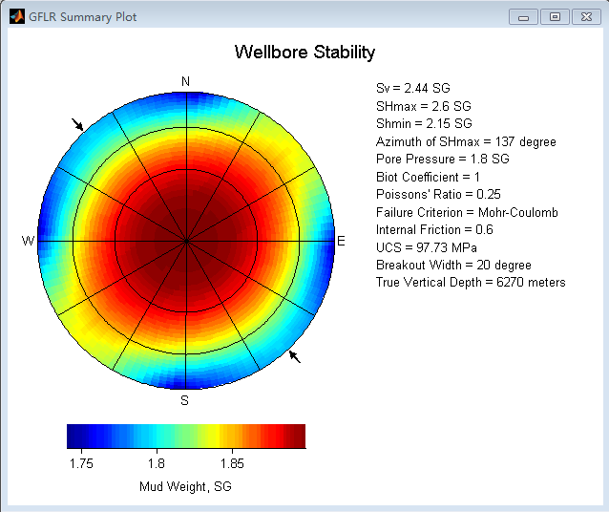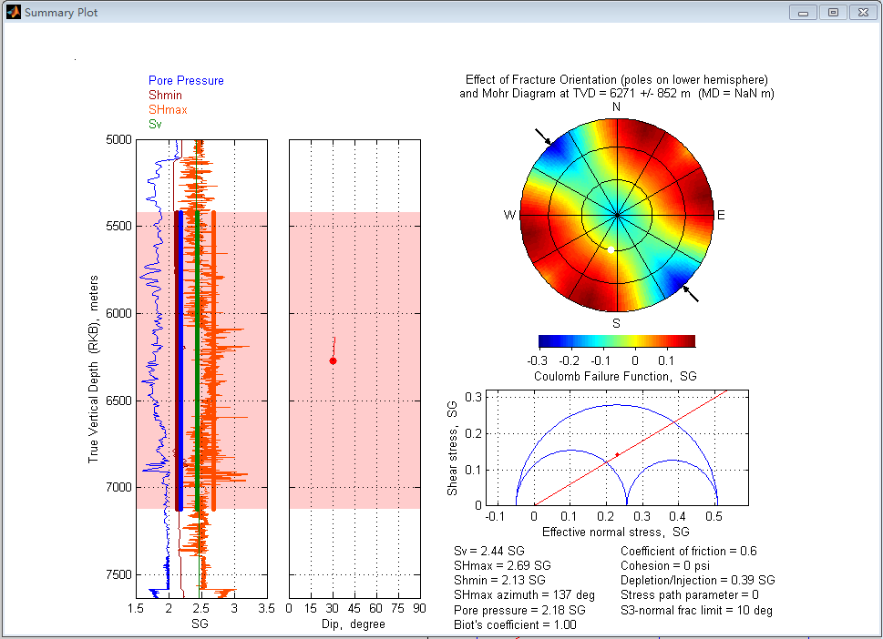

Fault collapse pressure 1.86 Fault leakage pressure2.15

**Fig. 5.** Fault pressure prediction

***3.4 Full wellhole speed up***

**3D drillability distribution model of Zhongqiu block**

Conduct formation core mineral composition, rock strength and drillability testing. Based on this, the drilling resistance profiles of 52 wells were established by using the logging data of Zhongqiu block. From top to bottom, the drilling resistance of the formation deteriorates. The Kangcun Formation is the most difficult formation to drill in this well area, and the drilling resistance is grade 6-8. The clustering algorithm is used to classify the rock strength of 52 wells vertically, and the seismic data is used as the constraint to identify the faults and structures. The PETREL software is used to establish the three-dimensional rock mechanics section of the Zhongqiu block, which is designed for the drill bit for the glutenite heterogeneous formation, improvement and optimization provided the basis (Fig. 6) . From the perspective of the three-dimensional drillability model, the compressive strength and heterogeneity distribution generally increase gradually from top to bottom, reaching the largest in the Kangcun Formation, up to 180Mpa. The abrasiveness index and heterogeneity gradually increased from top to bottom, reaching the largest in the Kangcun Formation, up to level 10. Some strata in the Kuqa Formation are more abrasive than the Kangcun Formation.

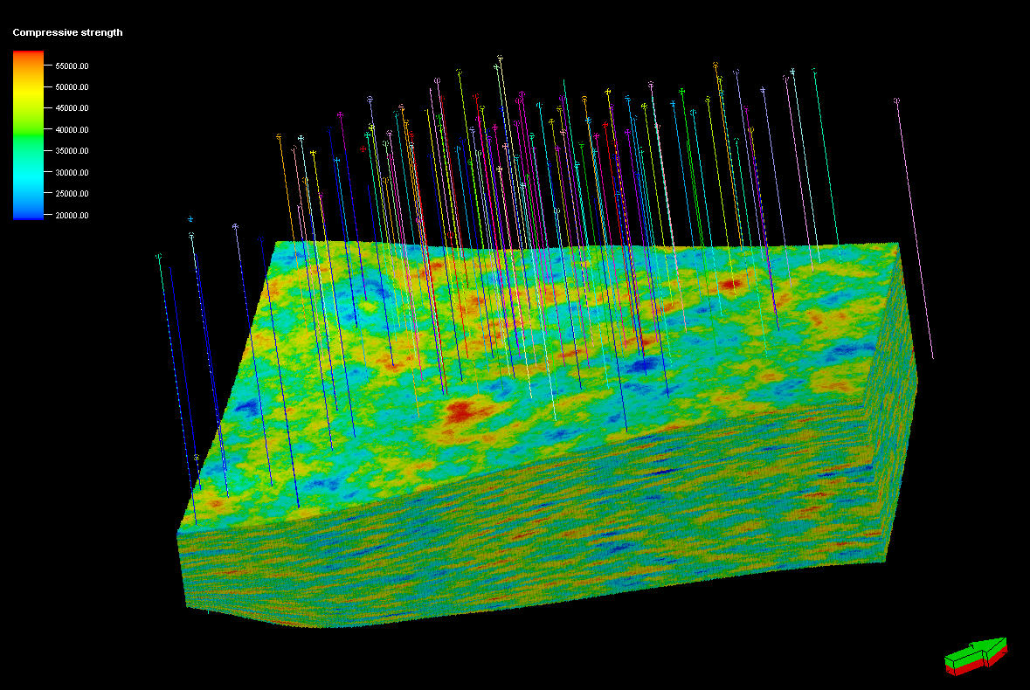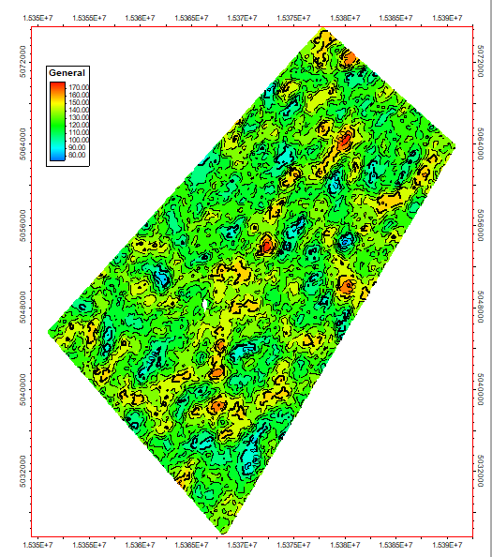

**Fig. 6.** 3D drillability distribution model of the Zhongqiu block

**Suprasalt speed up**

Based on the research in geology-engineering integration, and after deepening the understanding of suprasalt stratum lithology and bit working state, optimizing the plane design of cutting tooth center, bit tooth layout and diameter retaining design (Zhu et al., 2019; Wu et al., 2020), we have researched and developed SDR616 specified PDC bit with high impact resistance and long service life. For this bit, the 16mm cutting teeth are used to improve the tooth layout density of shoulder. Six-blade structure with 3 long blades and 3 short blades is adopted. The main cutting teeth are 6 more than that of the conventional five-blade bit, which enhances the stability and service life of the bit. Double rows of teeth are at the shoulder and stable torque teeth are at the core; To improve the bit stability, integrated structure and 4-inch diameter retaining are adopted, which make it applicable to stably inclined well section. The drill bit test results in the quasi diagenetic section and diagenetic section of conglomerate layer (Fig. 7) showed that the average footage of a single drill bit was high and the drilling speed was fast. Optimize the bit parameters through continuous process of R&D, test evaluation, improvement, and re-test. As well, the conventional “passive inclination prevention” drilling technology is difficult to deal with the salt formation with large dip angle (15 ° ~ 87 °). In order to solve the problem of deviation prevention and fast drilling in high and steep formation, specified foreign vertical drilling tools were introduced, and a standard operation mode was established to form a inclination-prevention fast drilling technology for high and steep structure, of which the mechanical ROP was 3 ~ 6 times higher than that of conventional drilling, and the well inclination was controlled within 1 °. In order to reduce vibration and improve the service life of drilling tools, shock absorbers and other speed-up tools were selected in the well section of gravel layer with lithology (non diagenetic, quasi diagenetic and diagenetic), and strengthening measures such as high WOB, high speed, high pump pressure, large displacement and large torque were adopted to further improve the mechanical ROP of the upper huge thick gravel layer.

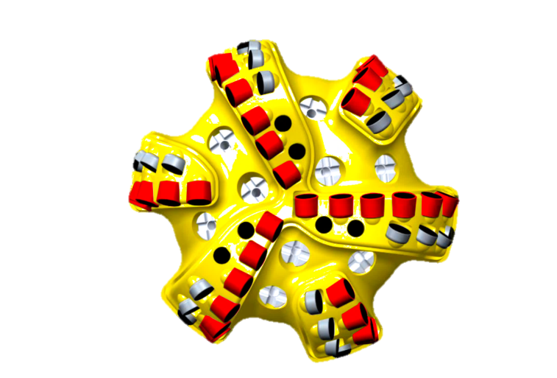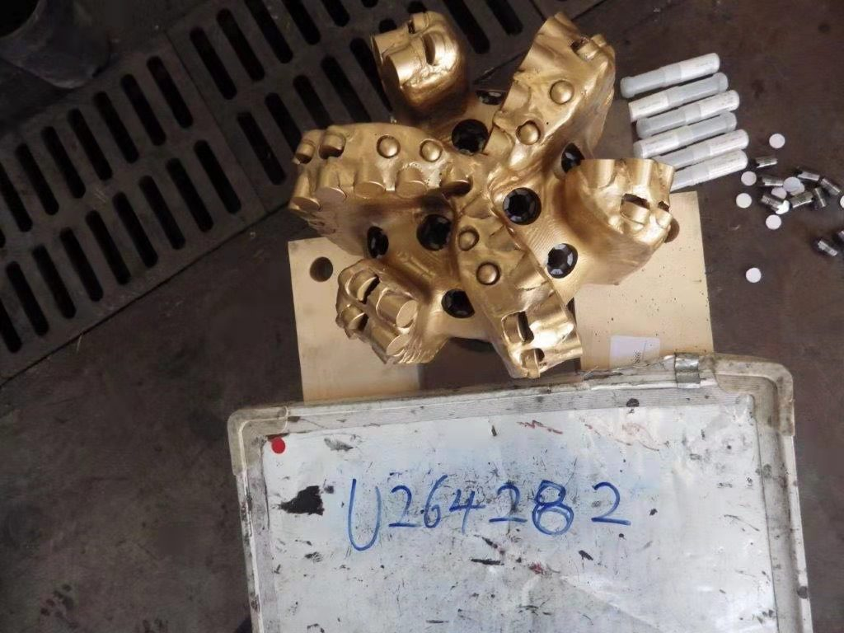

**Fig. 7.** SDR616 specified PDC bit

**Salt layer speed up and safe drilling**

There are great challenges in how to safely drill the salt layer, because the salt layer has the following features: ① the high content of chloride ion and calcium ion is easy to cause the thickening and poor flow performance of water-based drilling fluid; ② The intercalated mudstone is easy to hydrate, resulting in hole instability; ③ High pressure salt water layer is easy to damage the tectonic force of water-based drilling fluid and cause heavy powder settlement; ④ Under the condition of “high density, high salinity and high temperature”, the stability of water-based drilling fluid is poor. In order to realize the safe drilling in salt layer, it is necessary to be carefully in the fine correlation of stratum and the analysis-while-drilling of high-pressure brine and weak layer, so as to continuously improve the accuracy of geological prediction. On this basis, combined with the geological features of the salt layer, the oil-based drilling fluid with high density, strong inhibition, high temperature resistance, salt resistance, calcium resistance and salt water damage resistance is used to overcome the drilling “fortress” of drilling in ultra deep salt gypsum layer. In addition, on the basis of “waterproof and pressure relief”, explore the fine pressure control well drilling and completion technology, and tackle the problem of complex accidents and high timeliness during the drilling and completion of salt gypsum layer by accurately controlling the well bottom pressure under the condition of narrow density window. Through the deepening of the research on geology-engineering integration, the horizontal and vertical development of salt layer in Zhongqiu block was clarified (Cao et al., 2020; Teng et al., 2016). Then a layer of salt-blocking casing was designed for the case of single salt layer,deep buried depth of salt top, and thin salt layer, and a two layers of salt-blocking casings were designed in the case of shallow buried depth of salt top, thick salt layer or two sets of salt layers. The comparison results of the drilling time suggest that in the case of the salt top layer sticking, after drilling and uncovering the salt top for 1 ~ 2m, the salt can be seen and the intermediate completion can be achieved, and that in the case of salt bottom layer sticking, this purpose was realized through the combination of stratigraphic correlation, element logging and slim hole test drilling. At the same time, a clear intermediate completion principle of salt bottom sticking was formulated, so that the success rate of salt bottom layer sticking in mature blocks was higher than 90%.

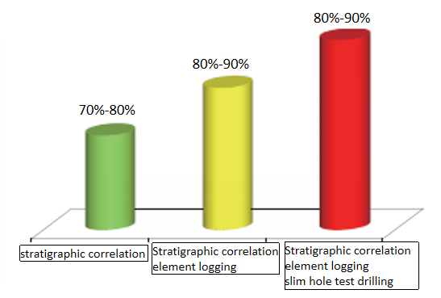

**Fig. 8.** Comparison of success rate of salt layer sticking by different technical means

**Subsalt speed up**

Based on the evaluation of rock drillability and drilling efficiency, the normalized drillability analysis of the whole well section was carried out (Fig. 9) . Among them, Xiyu formation was sandstone mudstone interlayer with high drillability class value, but the hardness was high in general; The drilling specific energy curve fluctuated violently, indicating that the penetration depth of the bit is uneven and the drilling tool has stick-slip vibration. The practical drilling suggested that the composite sheet collapse was more serious. Kuqa formation and Kangcun formation were homogeneous sandstone with quartz content of 45% ~ 65%, indicating that they were strong grinding stratum; Its underground vibration was weaker than that of Xiyu formation, so the demand for bit aggressiveness was small. The bit parts that were severely worn were mainly at the shoulder and nose. According to the combined analysis of geomechanics and engineering practice, the drill bit of Xiyu formation has high tooth distribution density and weak aggression, the depth of the composite sheet into the formation is low, and the composite sheet is almost free of wear. Therefore, the high-efficiency abrasive resistance PDC bit with certain aggression should be preferred (Yang et al., 2011) to improve the drilling speed of the machine; The bit parts that were severely worn in Kuqa group and Kangcun group were mainly at the shoulder and nose, and some composite pieces had jumping teeth and annular grooves. abrasion resistance PDC bits with certain impact resistance should be preferred to improve the per-bit footage.

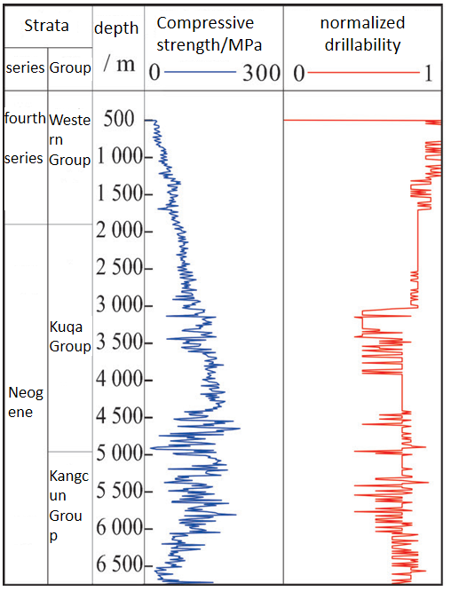

**Fig. 9.**Drillability analysis diagram of the whole well section

**Geomechanical model reconstruction-while-drilling and secondary pressure prediction**

Re calibrate the seismic data by using the logging and VSP data of the upper drilled formation, and carry out wave impedance inversion to obtain the wave impedance data of the lower undrilled formation and reconstruct the petrophysical model of the undrilled formation, so as to achieve the secondary prediction of stratum pressure based on the drilling engineering data of the drilled formation. On this basis, predict the rock mechanics, crustal stress data of undrilled formation, correct the collapse pressure, leakage pressure and salt rock creep model, and put forwards the suggestions on the optimization of safe drilling fluid density window and drilling fluid performance (Sun et al., 2011). By adjusting the density of drilling fluid in real time, effectively reduce the risk of well control, improve the ROP, and optimize the casing running position, so as to avoid the continuous occurrence of underground accidents.

**4 Conclusion**

From the whole life cycle of drilling such as well location deployment, trajectory optimization, drilling design and drilling speed increase, this paper systematically combed the necessity and implementation scheme of the implementation of geology-engineering integration under the background of Qiulitage complex structure in Tarim Basin. The geology-engineering integration effectively coordinates the collaborative work between geological research and engineering implementation, and organically integrate the purposes of “geological research service engineering” and “engineering achieves geological purpose”, so as to make the pre-drilling engineering scheme design more scientific and gives better quantitative basis for the engineering parameter adjustment during the drilling.

Taking Zhongqiu 10 well in the middle of Qiulitage tectonic belt as an example, this paper explained the main steps of geology-engineering integration practice, and the 3 wells deployed were significantly better than the vertical wells deployed in the early stage without considering geology-engineering integration in terms of drilling complexity reduction and drilling speed and production increase. Thus, the feasibility and superiority of geology-engineering integration based on geomechanics was presented. It is proved that the working concept and key technology of geology-engineering integration are not only applicable to the ultra deep oil and gas drilling project in Tarim Basin, but also have a good reference for the exploration and development of ultra deep and complex oil and gas in other petroliferous basins in Western China.

The improvement of the use efficiency of multi-disciplinary data is still the basic work that can not be ignored in the research in geology-engineering integration. At present, Tarim Oilfield has built a number of exploration and development database systems, which basically realizes the centralized management and data sharing of multidisciplinary data. But the problem of information island still exists, and the timeliness and data deep mining are still insufficient. In order to provide a more solid foundational guarantee for the research in geology-engineering integration, it is necessary to realize the deep integration and effective mining of multi-disciplinary data through the remote decision support center for drilling and completion and the integrated data platform of geology-engineering, so as to form a "remote, integrated, real-time, visual and diversified" integrated organization and management mode of geology-engineering.

**Acknowledgments**

The authors would gratefully like to acknowledge the financial support from National Science and Technology Major Project "Deep and Ultra-Deep Well Efficient and Rapid Drilling Technology and Equipment" (No. 2016ZX05020-002) and National Key R&D Program "Intelligent Rock Breaking Mechanism and Steering Control Method in Complex Formations" (No. 2019YFA0708302).

**References**

1. Xian Chenggang, Zhang jiehui, Chen Xin, Liang Xing, Wen Heng, Wang Gaocheng. Application of geomechanics in geology-engineering integration [J] China petroleum exploration, 2017,22 (1): 75-88.
2. ZOBACK M D. Reservoir geomechanics[M]. Cambridge: Cambridge University Press, 2010.
3. Ma Y Z. Uncertainty analysis in reservoir characterization and management: How much should we know about what we don’t know[J]. AAPG Memoir 96, 2011:1-15.

Yu Xinghe, Ma Y Zee, David Psaila, Paul La Pointe, Ernest Gomez, Li Shengli. Reservoir characterization and modeling: A look back to see the way forward[J]. AAPG Memoir 96, 2011:289-309.

CIPOLLA  C  L,  FITZPATRICK  T,  WILLIAMS  M  J,

et  al.  Seismic-to-simulation  for  unconventional  reservoir development［C］//SPE Reservoir Characterisation and

Simulation  Conference  and  Exhibition,  October  2011,

Abu Dhabi, UAE. DOI: 10.2118/146876-MS.

GUPTA J K, ZIELONKA M G, ALBERT R A, et al. Integrated methodology for optimizing development of unconventional gas resources［C］//SPE  Hydraulic   Fracturing  Technology  Conference,  February  2012,  The Woodlands, Texas, USA. DOI: 10.2118/152224-MS.

MARONGIU-PORCU M, LEE D, SHAN D, et al. Advanced modeling of interwell fracturing interference: an eagle Ford shale oil study［J］//SPE Annual Technical

Conference  and  Exhibition,  September  2015,  Houston,

Texas, USA. DOI: 10.2118/174902-PA.

1. Wu Qi, Liang Xing, Xian Chenggang, Li Ju. Geology-engineering integration and efficient development of marine shale gas in southern China [J] China petroleum exploration, 2015,20 (4): 1-23.

Hu Wenrui. Geology-engineering integration is the only way to realize the effective exploration and development of complex reservoirs [J] China petroleum exploration, 2017,22 (1): 1-5.

COHEN C E, KAMAT S, ITIBROUT T, et al. Parametric study

on completion design in shale reservoirs based on  fracturing-to-production  simulations［C］//International Petroleum Technology Conference, January 2014, Doha, Qatar. DOI: 10.2523/IPTC-17462-MS.

MAXWELL S C, WENG X, KRESSE O, et al. Modeling microseismic hydraulic fracture deformation［C］//SPE  Annual  Technical  Conference  and  Exhibition,

September  2013,  New  Orleans,  Louisiana,  USA.  DOI:10.2118/166312-MS.

WENG X, KRESSE O, CHUPRAKOV D, et al. Applying complex fracture model and integrated workflow in unconventional  reservoirs［J］. Journal  of  Petroleum

Science and Engineering, 2014, 124: 468-483.

1. Jia Chengzao. Tectonic features and hydrocarbon accumulation law in Tarim Basin [J] Xinjiang Petroleum Geology, 1999, 20 (3): 177-183.
2. Tang Liangjie, Li Jingchang, Yu Yixin, et al. Discussion on differential deformation and segmentation features of salt structure in Kuqa Foreland Fold thrust belt [J] Journal of geology, 2006, 80 (3): 313-320.
3. Xiong Jiyou, Pu Keyong, Zhou Jian. Study on rock drillability of ultra deep wells in piedmont structure of Kuqa depression [J] Natural gas industry, 2009, 29 (11): 59-61.
4. Wang Zhaoming, Zhong Dakang, Sun Haitao, et al. Sedimentary features and distribution law of Neogene quaternary gravel strata in the middle of Kuqa depression [J] Acta sedimentologica Sinica, 2013, 31 (2): 282-290.
5. Li Liuwei, Lian Zhanghua, Shi Chongping, et al. Analysis of hole creep shrinkage in inclined salt rock section [J] Natural gas industry, 2006, 26 (8): 65-68.
6. Rojas, Leonardo , Tveritnev, Alexey , and Carlos Pinillos. "Rock Type Characterization Methodology for Dynamic Reservoir Modelling of a Highly Heterogeneous Carbonate Reservoir in Abu Dhabi, UAE." Paper presented at the Abu Dhabi International Petroleum Exhibition & Conference, Abu Dhabi, UAE, November 2020.
7. GALE J F W, HOLDER J. Natural fractures in the Barnett shale: Constraints on spatial organization and tensile strength with implications for hydraulic fracture treatment in shale-gas reservoirs[C]//The 42nd U.S. Rock Mechanics Symposium (USRMS), 29 JUNE-2 July 2008, San Francisco, California,USA.
8. INFANTE E F, CHENEVERT M E. Stability of boreholes drilled through salt stratums displaying plastic behavior[J]. SPE Drilling Engineering, 2013, 4(1): 57-65.
9. Cozyris, K.M.. M., Churcher, P.L.. L., Piland, J.R. R, Maharidge, R.L.. L., Adamson, M.D.. D., and R.. Lew. "An Integrated Engineering and Geological Approach to the Design of Horizontal Multistage Fracture Completions in the Tonkawa and Cleveland Tight Oil Sandstones in Dewey County, OK." Paper presented at the SPE Production and Operations Symposium, Oklahoma City, Oklahoma, USA, March 2015. doi: [https://doi.org/SPE-173586-MS](https://doi.org/SPE-173586-MS" \t "https://onepetro.org/SPEOKOG/proceedings/15POS/All-15POS/SPE-173586-MS/_blank)
10. Wu Chao, Chen Mian, Jin Yan. Prediction of pre-drilling borehole wall stability using seismic inversion technology [J] Petroleum drilling and production technology, 2006 (2): 18-20.
11. Zhu Xiaolin, Yang can, Zhang ou, et al. Conglomerate rock breaking technology and application of new PDC bit [J] Petroleum machinery, 2019, 47 (6): 28-32.
12. Wu Zebing, Zhang Shuai, Wang Yongyong, et al. Parametric tooth arrangement and rock breaking simulation of PDC bit based on ABAQUS [J] Petroleum machinery, 2020, 48 (3): 30-36.
13. Cao Yang, Wang Haitao. Research on cutting structure design of rotary cutting PDC bit [J] Petroleum machinery, 2020, 48 (7): 42-48.
14. Teng Xueqing, Chen Mian, Yang Pei, Li Ning, Zhou Bo. Full hole acceleration technology for ultra deep wells in Kuqa foreland basin [J] China petroleum exploration, 2016,21 (1): 76-88.
15. Yang Zhonghan, he Shiming, Zhou Xiaohong, et al. Review of bit optimization methods at home and abroad ［ J ］. Journal of Chongqing Institute of science and Technology (NATURAL SCIENCE EDITION), 2011, 13 (4): 87-90.
16. Sun Haifang, Qian Haodong, Yang Chengxin, et al. Using drilling database to build remote drilling auxiliary decision planning [J] Drilling and production technology, 2011, 34 (6): 1-3.

Introduction：CHEN Chang-chang (1993-), male, doctor, engineer, mainly engaged in the research and development of efficient rock breaking and PDC bit

Company: CNPC Engineering Technology R&D Company Limited

Tel：010-80162243

Mobile：18810060792

E-mail: chenccdr@cnpc.com.cn

Address: Building 1, yard 5, Huanghe street, Changping District, Beijing